**Assignment-2**

**Om Vaknalli**

**Roll No. : 18376**

**Assignment 2**

1a.

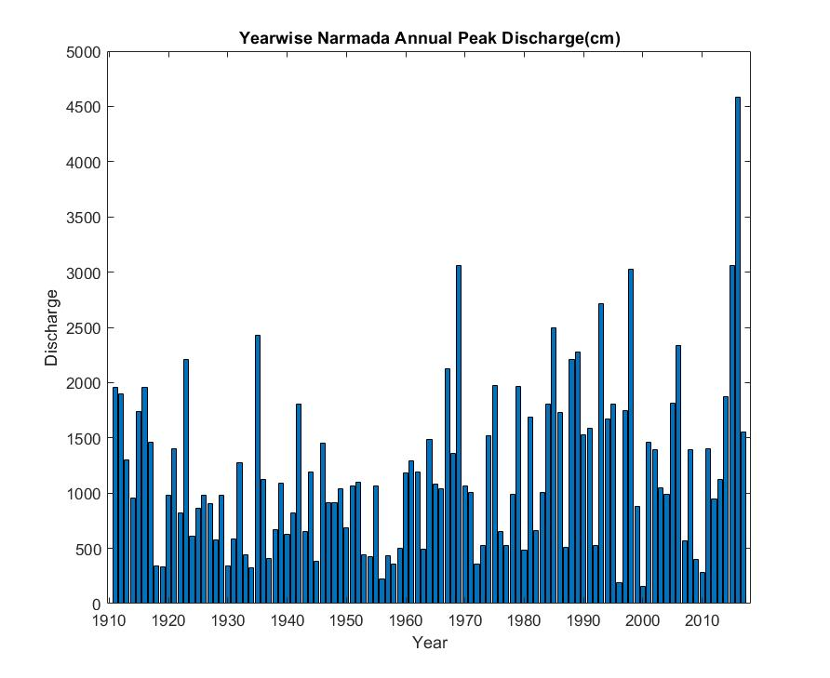

1.b) 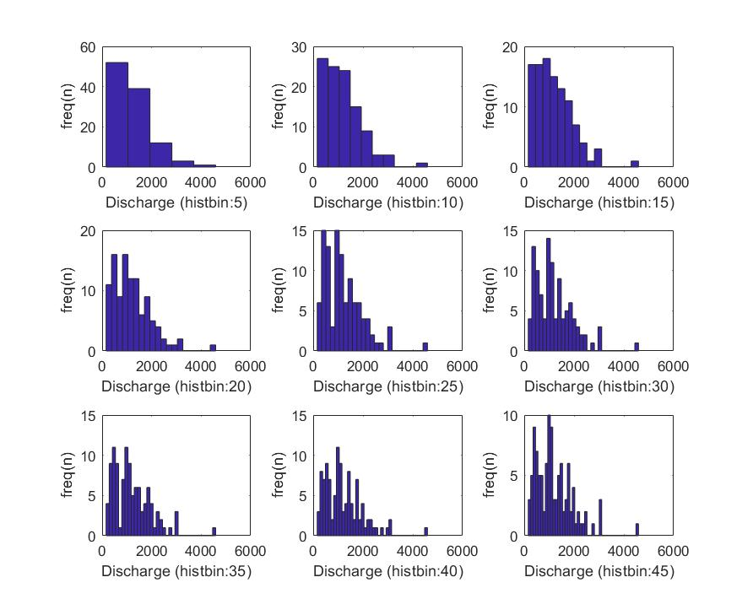

The smaller binsize defeats the purpose of plotting the histogram as it is too course.The higher bin sizes gives too much finer details which is also not the purpose of the histogram.Binsize of30/35 looks an optimized one to represent the data, being not too fine or too course.

1.c)

Mean = 1.2045e+03

Median =1062

Max =4587

Min =159

SD =753.7866

IQ_Range =1.0575e+03

Skewness = 1.3016

1.d)

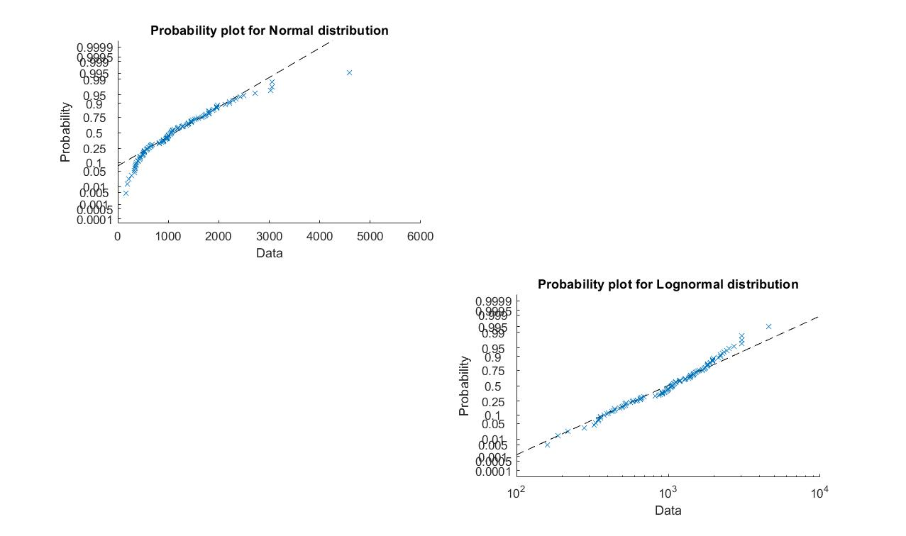

1.e) muhat = 1.2045e+03

sigmahat =753.7866

PARMHAT = 6.8925; 0.6696

1.f) for normal distribution = 2.9581e+03

For log normal distribution= 4.6761e+03

1.g) P_norm = 3.6059e-06

P_log =0.0108

1.h) alpha =587.7250

Beta= 865.3007

1.i) 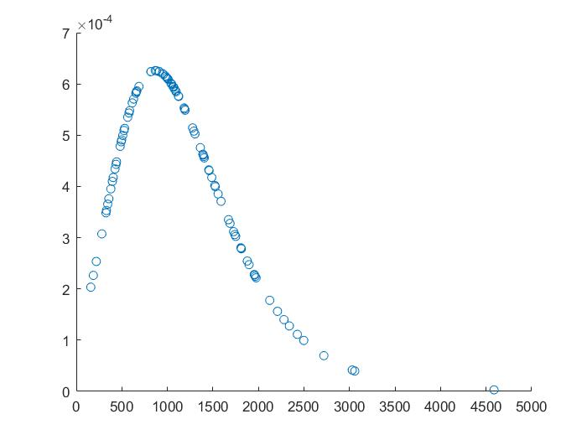

X(cm)

f(x)

1.j) ans = 3.5689e+03

1.k) 0.9982

2. Probability of a 100-year event will not be exceeded in 50 years,

P(x<X) = 0.99

P = ${0.99}^{50}$ = 0.605

Probability of a 100-year event will be exceeded once or morein next 50 years,

P(x>X) = 1- P(x<X)

P= 1- ${0.99}^{50}$ = 0.395